Lab 2.1-3, 2.6

Question 1

It returns the albedo divided by pi for each channel, because our albedo is 1,1,0 it returns 1/pi for the red and green channel and 0/pi=0 for the blue channel. The divison by pi is there for energy conservation.

Question 2
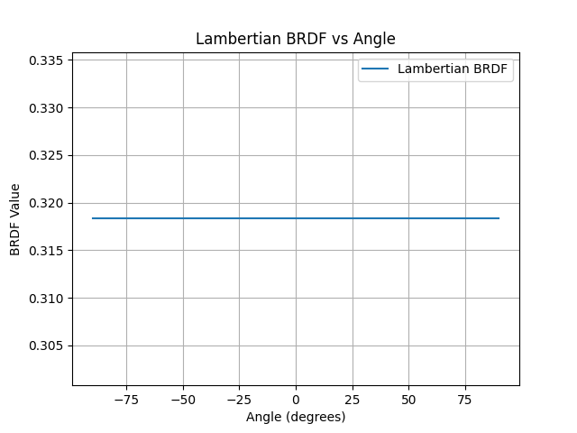
Question 3
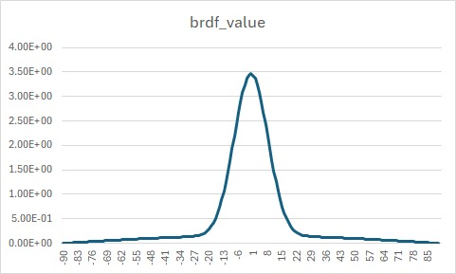

Lab 2-6

We are comparing the following 3 models:

- shaderModel == 0: Lambert
- shaderModel == 1: Blinn-Phong
- shaderModel == 2: Cook-Torrance

Good shader to mimic real-world objects and parameters:

- Lambert: best for diffuse materials like chalk, just base color no roughness or metallic parameter
- Blinn-Phong: best for smooth materials like palstic, base color and shininess parameter
- Cook-Torrance:best for realistic materials with rough surfaces like metal, base color/ albedo and roughness and metal parameter

Limits of models

- Lambert: reflective surfaces
- Blinn-Phong: rough surfaces, metals
- Cook-Torrance: high computation

Sensible parameters are:

- Blinn-Phong: 250 shininess is a good value for plastic
- Cook-Torrance: for smooth surfaces like glass roughness parameter of 0.2, rough surfaces 0.9 and metal parameter of 1 for metals and 0 for non metals like plastic

